**Partnership Agreement**

This contract is made between Ihab El-Waly and Vijaysinh Parmar

**Ihab El-Waly**, and **Vijaysinh Parmar** shall agree on the following conditions in order to work with each other professionally.

1. Ihab shall own 60% of the pet website business, and Vijaysinh shall own 40% of petlanda.com
2. Petlanda.com shall be a property of EagleWebz INC.
3. Ihab shall be responsible for business development, researching for newer ideas, offline marketing and managing Vijaysinh ‘s work.
4. Vijaysinh shall be responsible for the Web Development and basic Online Marketing.
5. As an initial Ihab shall be funding the website, and Vijaysinh shall be funding his time.
6. Once the website starts making revenues, both Ihab and Vijaysinh shall be reinvesting in it and keeping the remaining for personal use.
7. Both Ihab and Vijaysinh must be putting enough efforts in order to make this business successful, and failure to put efforts shall change percentage of the business for one side or have one side substituted with another business partner.
8. All the revenues shall go to EagleWebz INC, and Ihab shall be transferring 40% for Vijaysinh biweekly according to the profits made.
9. After the initial stage Ihab and Vijaysinh shall decide on a fair manner regarding the business % of shareholders, and may increase or decrease the % of profits for Vijaysinh.
10. If one party fails to abide by one of those conditions then partnership shall be terminated, making the two parties in loss.

Signature of **Ihab El-Waly:**

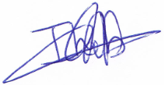

Date of Signature: Jan 08, 2014 (New York Time zone)

Ihabow2003@hotmail.com

Signature of the **Vijaysinh Parmar:**

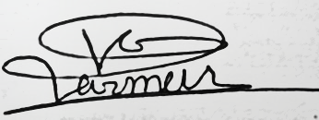

Date of Signature: Jan 08, 2014 (New York Time zone)